**WICKY WINNER**

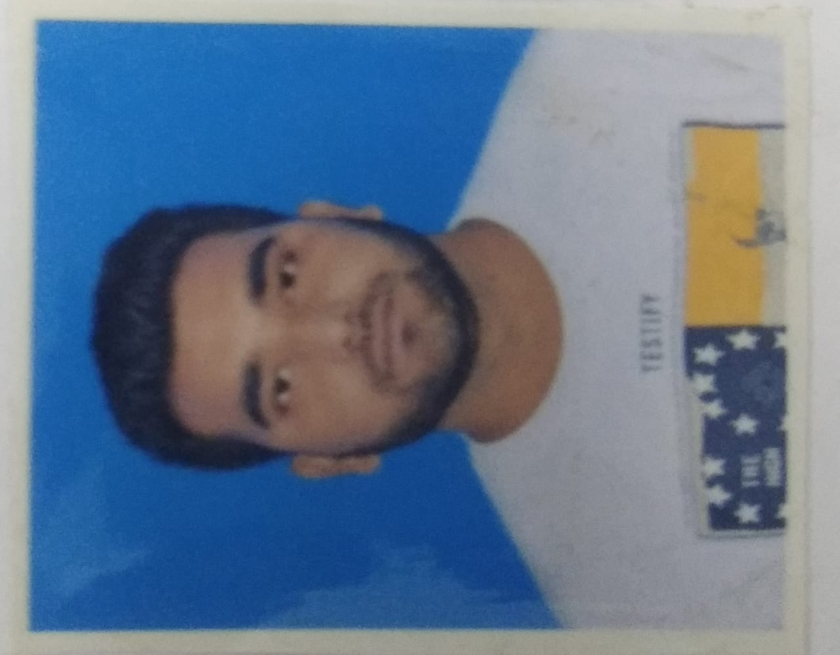

Haldia Institute of Technology, Haldia, West Bengal

Speaker Phone**+91 9110028224** |Email[**winner312.com@gmail.com**](mailto:winner312.com@gmail.com)**|  wickywinner**

|  |
| --- |
| Career Objective: |
| A dynamic, energetic, enthusiast, engineering student looking for opportunities in an organization of repute to kick-start the career by utilizing the knowledge, skills & abilities gained during the academic tenure so far to attain the organizational as well as professional growth. |

|  |  |  |  |  |  |  |
| --- | --- | --- | --- | --- | --- | --- |
|  | | | | |  | |
| Courses | **Institution** | **Board/University** | **Year of Passing** | **Percentage/CGPA** | | |
| B. Tech in Electronics and Communication Engineering | Haldia Institute of Technology | Maulana Abul Kalam Azad University of Technology **(MAKAUT)** | 2021 | **Sem.**  5 | **SGPA**  7.96 | **Average** |
| 4 | 8.27 | 7.82 |
| 3 | 7.90 |
| 2 | 7.31 |
| 1 | 7.67 |
| XII | S.D.M INTER COLLEGE BISHANPUR,SAHARSA Bihar | Bihar School Examination Board  **(BSEB)** | 2016 |  | 67.2 | |
| X | BUDDHA PUBLIC School,SAHARSA[BIHAR] | Central Board of Secondary Education  **(CBSE)** | 2014 |  | 9.6 CGPA | |

|  |
| --- |
| Software Proficiency |
| * Programming in C * Python Programming * Core Java * DBMS |

|  |
| --- |
| Trainings and Workshops: |
| * Programming in C   Jan-Feb 2019 Patna ,Bihar  Reg no - R190001200531  NIIT Patna  Core Java  June - July 2019 Hyderabad  Naresh Technologies  In-House winter training on Python programming and DBMS  Jan – Feb 2020 Haldia Institute of Technology, Haldia, West Bengal. |

|  |
| --- |
| Achievements and Projects: |
| * Project on creating GUI “kwizz” using tkinter module * Project on creating GUI “irctcapp” (provides train route using train number) using Railway API. |

|  |
| --- |
| Personal Information: |
| * Father’s Name : Akhilesh Kumar Verma * Mother’s Name : Sangita Kumari * Date of Birth : 3rd August 1999 * Gender : Male * Nationality : Indian * Languages Known : English &Hindi * Permanent Address : Lovely Anand Path, Naya Bazar ,Saharsa, PIN-852201 [BIHAR]      * Hobbies : Playing Cricket, Listening Songs |

|  |
| --- |
| Declaration: |
| I solemnly declare that all the above information is true and correct to the best of my knowledge and belief. |

**Place:**  Haldia, West Bengal

**Date:**05-03-2020

**(Wicky Winner)**